SYSTEM ANALYSIS

In this chapter, the current system’s contribution, procedures and productions are deeply discussed to show how the system components interact. For accurate analysis of the new proposed system to be done, some fact gathering techniques like questionnaires, interviews, record inspection and observations are used to collect data. The best alternative is therefore the new proposed system. In simple terms, the aim of the analysis phase is to specify requirements thus the functional and non-functional requirements of the proposed system are specified herein. [1]

2.1. INFORMATION GATHERING TECHNIQUES

A methodology is defined by two things which are the detailed research methods through which collection of data is done and the viewpoints upon which the collection and evaluation of data are based. In order to have knowledge regarding, information gathering techniques were used and these were questionnaires, observations and interviews. In order to define the requirements of a system, facts must be gathered from the participants. Ideally, the information acquired will allow a well-defined, accurate, and complete explanation of how the institute functions as well as the students and lecturers, functions and data involved. [2]

2.1.1. TRADITIONAL METHODS

Information below was gathered from different users, which needed to delivery for students and lecturers.

Interviews:

Basically, the focus of the interview was on seeking views and clarification from the internal and external interested parties (Participants, one of the limiting factor during interviews is bias which in this case the interviewer avoided such bias and or prejudice by asking context free questions that refrain from the respondent’s agreement or disagreement.)[3]

Questioning:

By questioning all those who are involved in this business venture including students / lecturers / other staff will help on how to improve the system through their complaints. Hearing what their say and help to build a system which is convenient and user friendly. [4]

Questionnaires:

According to Laws et al (2013), a questionnaire is a list of questions either given or sent to respondents who fill the questionnaire themselves. Questionnaires are another way of data gathering which was used to collect information at UZ School of Technology. A mass production of questionnaire was done and these questionnaires were distributed. [5]

Observation

Records Inspection

Study of existing organizational documents, forms and reports. This is the study of organizational charts and statistics that show useful information about a certain procedure. In order to gain an insight on the pass rate level of students in the previous years, record inspection was done.

DATA FLOW DIAGRAM

DFD MODELLING

Refer as articulated that data analysis is a way to support decision making through evaluation of various data elements, modelling and transforming data so as to find useful information to reach a decision. Illustration of the data modelling is done by making use of data flow diagrams (DFD) that provide an easy way of visualizing object relationships. Data analysis enables one to use logical reasoning and analysis so as to develop a solution [6].

ACTIVITY DIAGRAM

Activity diagram for Library Management System. The activity diagram used to describe flow of activity through a series of actions and it is an important diagram to describe the system. It described as an action or operation of the system. Below are the activity diagram for librarian and students operations:

3. DESIGN

2.5 DATA FLOW DIAGRAM

DFD MODELLING

Refer as articulated that data analysis is a way to support decision making through evaluation of various data elements, modelling and transforming data so as to find useful information to reach a decision. Illustration of the data modelling is done by making use of data flow diagrams (DFD) that provide an easy way of visualizing object relationships. Data analysis enables one to use logical reasoning and analysis so as to develop a solution [6].

ACTIVITY DIAGRAM

Activity diagram for Library Management System. The activity diagram used to describe flow of activity through a series of actions and it is an important diagram to describe the system. It described as an action or operation of the system. Below are the activity diagram for librarian and students operations:

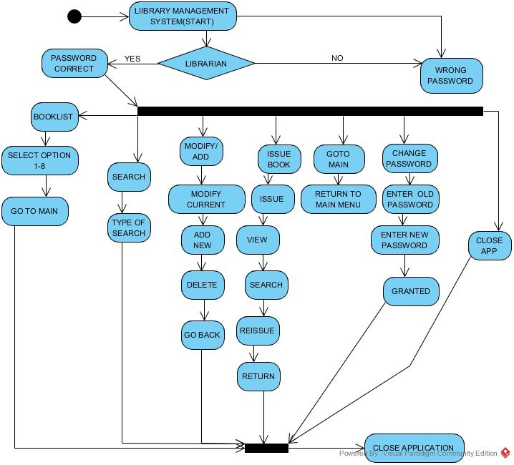

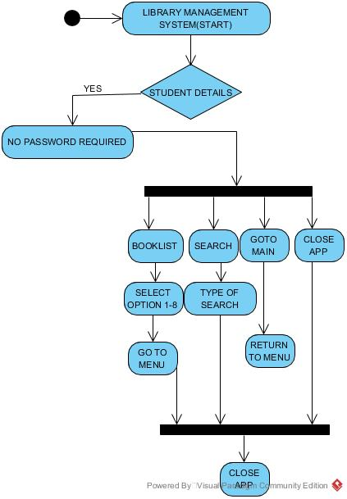

The use case diagram are usually referred to as behaviour diagram used to describe the actions of all participants partake in a system. All participants describe in use case are actors and the functionality as action of system.

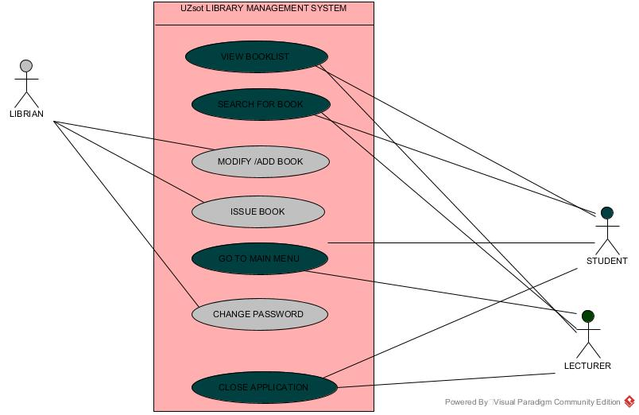

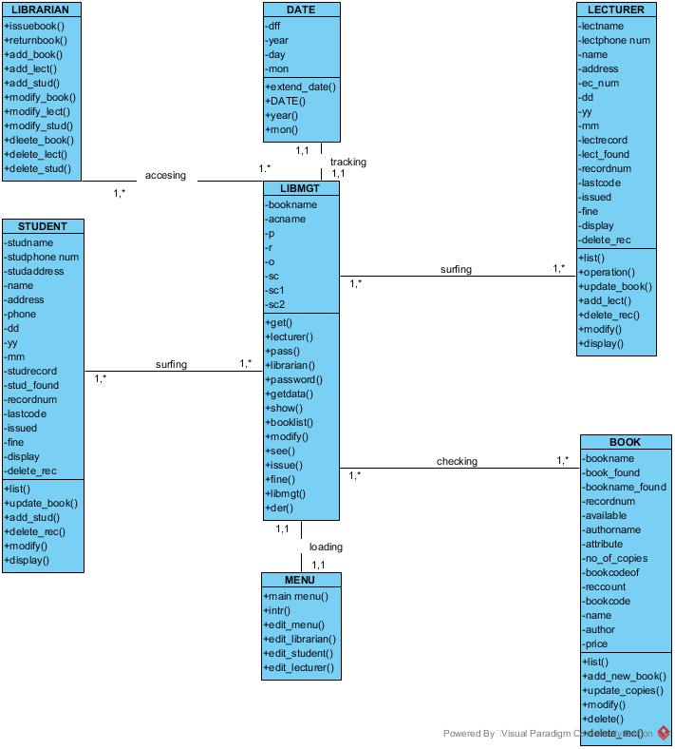

The analysis class design show the segmentation of the system and the outlook of the system interaction.

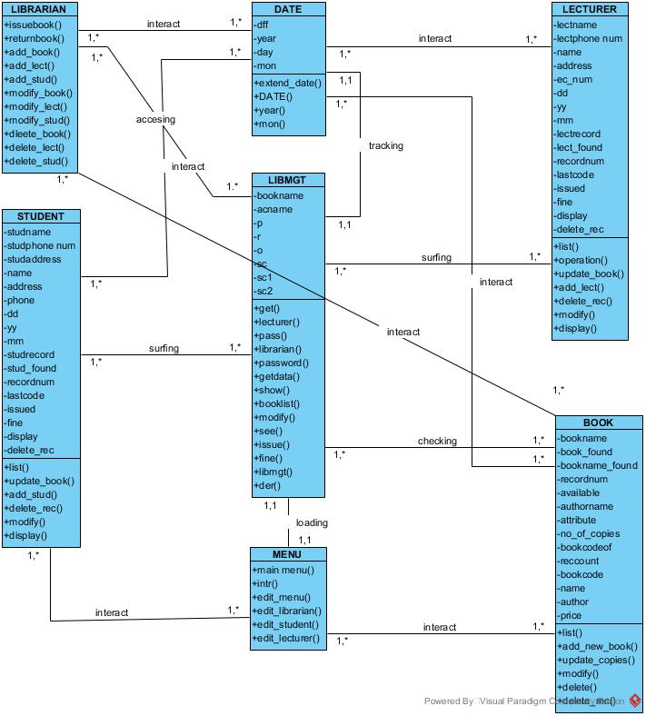

Sequence diagram descries interaction among classes in terms of an exchange of message over time. Sequence diagram demonstrate the behaviour of objects in a use case by describing the object and messages they pass.

